**Recover/Reset Root Password**

**1 – In the boot grub menu select option to edit**

[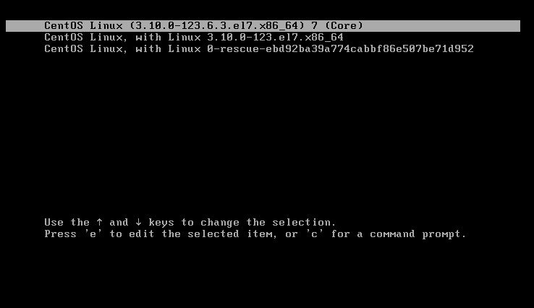](https://s24255.pcdn.co/wp-content/uploads/2014/09/Selection_003.png)

**2 – Select Option to edit (e).**

[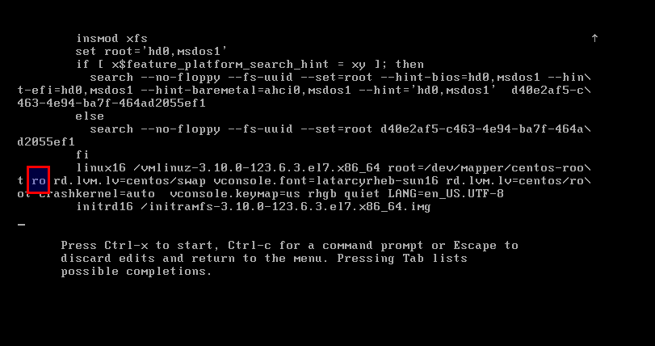](https://s24255.pcdn.co/wp-content/uploads/2014/09/Selection_005.png)

**3 – Go to the line = ro and change it with rw init=/sysroot/bin/sh**

[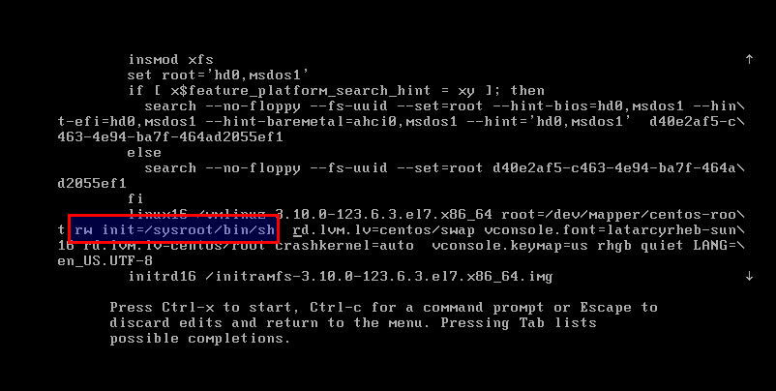](https://s24255.pcdn.co/wp-content/uploads/2014/09/Selection_006.png)

**4 – Now press Control+x to start on single user mode**

[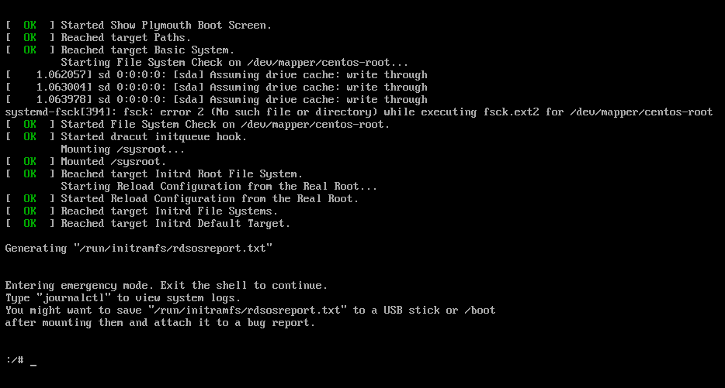](https://s24255.pcdn.co/wp-content/uploads/2014/09/Selection_007.png)

**5 – Now access the system with this command.**

chroot /sysroot

**6 – Reset the password.**

passwd root

**7 – Exit chroot**

**exit**

**8 - Reboot your system**

reboot